
Course | COMP 595: Cloud Computing Provisioning
Lab Assignment | Lab 8 – DevOps and Git
Instructor
Section
Student Name
Submission Date

Lab Overview
This lab activity will demonstrate how to connect industry standard IDEs such as Visual Studio and Visual Studio Code to create and publish web applications to Microsoft Azure using GIT.

Note 1: Variables in the commands are identified in this lab handout by enclosing them in % signs. For example, %username%.

Note 2: This lab can be completed from any computer with internet access, it is not run in Rancher.

Lab Activity 1 – Create a new WebApp in Azure
- Login to the Microsoft Azure account that you created in the previous lab.
- Create a new empty web app under the app services section of Azure. (It’s easiest to search for “App Services” in the search box.)
- Name your WebApp Lab9-%username% and create it your COMP595 resource group. Adjust the name if necessary to ensure it is unique. (lab8-%username% is usually available)
- Select the PHP 8.4 stack on Linux, and
- Use the Free F1 pricing plan, the click “review + create”
- Once the deployment completes, choose go to resource
- Open the deployment center, and pause there

Lab Activity 2 – Create a new site with Visual Studio Code
- If you do not already have a Github account, go to github.com and create one with your Fleming email address. Do not create a repository yet.
- Download Visual Studio Code from https://code.visualstudio.com/ and install it on your computer.
- Download Git from https://git-scm.com/downloads/win and install it.
- Run the following commands to set your identity
- git config --global user.name "Your Name"
- git config --global user.email "your.email”
- Create a new working directory on your computer called lab8.

Lab Activity 3 – Connect to GIT and Deploy
- Start Visual Studio Code
- Open your lab 8 folder
- In VS Code, create a new file called index.php from the contents in D2L (copy and paste) and place it in this directory. Do not make any changes to the content at this point.
- Use the source control link (third icon down) to initialize a git repository
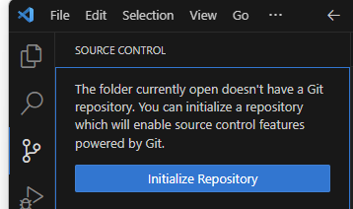
- Stage and commit your repo with “initial commit” for the comment, then publish the branch. Log into Github when prompted, then select “publish to GitHub public repository”
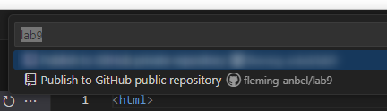

- Return to your Web App configuration in Azure and select the deployment center.
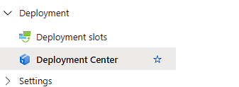

- Configure the source as GitHub, then fill in the blanks. Fill in the details, and click save. Chill out for 5 minutes while the app deploys.
- Return to the overview page (left hand menu). Click on the default domain link, and record a screenshot including the URL bar and the content.

Lab Activity 4 – Modify and Update
- Go to your Github repo and add a README file. The content should be “This is COMP595 Lab 8”
- From the command line, in your project directory, issue the “git pull” command. Take a screenshot.
- Return to VS Code and update the name in the index file to your own.
- Save the file. Note that the source control icon now has a counter for the uncommitted changes.
- Use the source control menu to commit your changes. Use “Lab activity 4” as the commit message.
- Sync the changes.
- Open the file explorer (in VS Code), then open the README.md file. Capture a screenshot showing the explorer and the open file.
- Wait a couple minutes, then refresh the web page you opened in the last step of Activity 3..
- Record a screenshot.

Focus Question
When you updated your code, you committed the changes to Github, but did not upload them to the Azure web server. How did the web page get updated?

Lab Submission
- If you used an existing GitHub account, the full URL for the public repository for this lab. I will be grading the contents of the repository.
- The URL for your application.
- All screenshots from Activities 3 & 4
- The answer to the focus question

